Day-3 Learning
- PySpark vs Pandas comparison
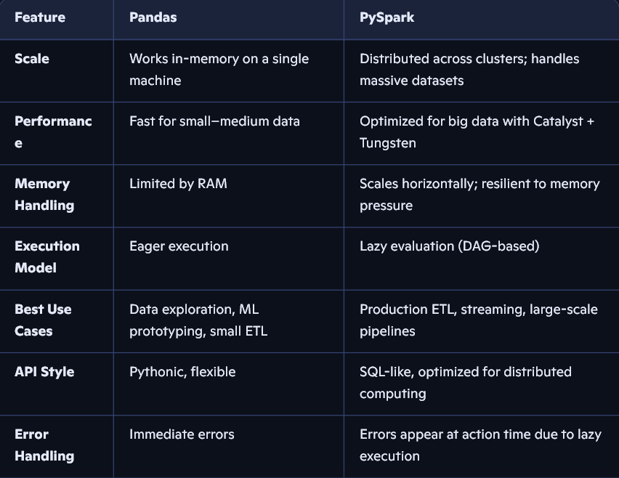


- When to Use What

- Choose Pandas when:
- Data fits in memory.
- You’re exploring, visualizing, or prototyping.
- You need quick iteration.
- Choose PySpark when:
- Data is too large for a single machine.
- You’re building production ETL pipelines.
- You need distributed compute.
- You’re working in Databricks or a cluster environment.

- Joins in Pyspark
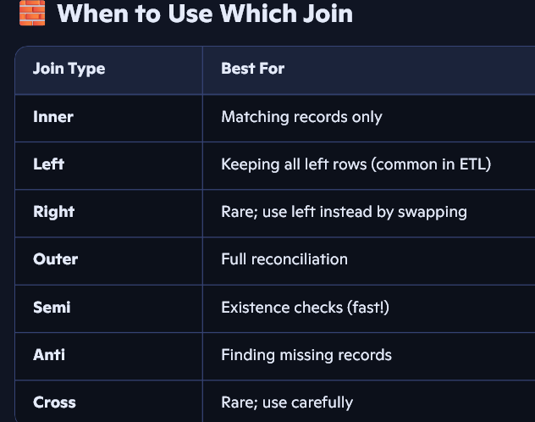
- Null Handling in Joins (Important!)
- In inner, left, right, outer joins:
NULL == NULL is false, so null keys do not match.
- In semi and anti joins:
Nulls behave the same — they never match.
- Performance Tips for Joins
- Broadcast Join
Use when one DataFrame is small (< 500 MB).
2. Avoid Skew
If one key has huge skew:
- Use salting
- Use skewHint
- Repartition by join key
3. Select Only Required Columns
Reduces shuffles size
4. Use Delta Z-Ordering or Clustering
Improves join performance on Databricks
- User defined functions (UDFs)
User-Defined Functions (UDFs) in PySpark let you extend Spark’s built-in functionality by writing your own custom logic in Python and applying it to DataFrame columns. They’re useful when Spark doesn’t provide a native function for a transformation you need.
Think of a UDF as a bridge:
You write Python code → Spark wraps it → Spark applies it row-by-row across the cluster.

